Form Field | Instructions
Provider Name: Click or tap here to enter text. | Enter agency’s name as it appears on your license. Include DBA (Doing Business As) if operating under a different name. Do not abbreviate.
Provider Federal Tax ID (FID) #: Click or tap here to enter text. | List the agency’s Federal Identification number.
Site Address: Click or tap here to enter text.  City/ State/Zip: Click or tap here to enter text. | The address of the licensed and/or contracted program or service in which the individual participates.
County of Program: Click or tap here to enter text. | The county in which the consumer’s program is located. If ambulatory service, identify the county in which the agency’s license or contract is issued.
Service(s) Provided: Click or tap here to enter text. | List the services the agency provided to the consumer at the time of the incident.
Incident Report Contact: Click or tap here to enter text.  Title: Click or tap here to enter text.  Contact Number: Click or tap here to enter text.  Email Address: Click or tap here to enter text. | List the person to contact when additional information is needed and to receive the Incident Notification containing follow up instructions.

Form Field | Instructions
Incident Date and Time: Click or tap here to enter text.  ☐ Unknown | List the actual date the alleged incident occurred. This is not a field for the date of discovery. List the date (mm/dd/yyyy) and Time (am/pm). If unknown, select the box.
Date and Time Known to Provider: Click or tap here to enter text. | This field is for the date of discovery by any agency staff (not when Administration learned of the incident.) List the date (mm/dd/yyyy) and Time (am/pm). If unknown, select the box.
Location of Incident: Click or tap here to enter text. | Record the exact location where the incident occurred. Include street, city, zip code. If location is unknown, write “unknown”.
Was this consumer on agency site or in presence of staff at the time of this incident? ☐ Yes ☐ No | Select Yes or No.
Allegation and/or Event: (Check all appropriate categories. Refer to Categories Grid for definitions.)  Allegations Events  ☐Abuse: Physical Choose an item. ☐Death Choose an item.  ☐Abuse: Verbal/Psychological ☐Medical Choose an item.  ☐Abuse: Sexual ☐Suicide Attempt Choose an item.  ☐Neglect Choose an item. ☐Overdose  ☐Exploitation: Financial Choose an item. ☐Injury (Moderate) Choose an item.  ☐Exploitation: Personal ☐Injury (Major) Choose an item.  ☐Professional Misconduct ☐Elopement/Walkaway  ☐Rights Violation ☐Physical Assault Choose an item.  ☐Sexual Assault ☐Operational Choose an item.  ☐Criminal Activity Choose an item.  ☐Contraband Choose an item.  ☐Unapproved Restraint Choose an item. |  | Select the allegation or event you are reporting AND select identifier from the drop down. Refer to the Incident Reporting Levels and Categories List for definitions.  A note on Media Interest: report if agency staff has seen the incident reported via a news outlet, or if agency feels there is a potential for some media inquiry/attention.
Provide a detailed description of the incident being reported:  Click or tap here to enter text. |  | Provide a detailed description of the incident being reported: Who, what, where, when and how it occurred. Be specific- Use full legal names. Do not use initials, nicknames, or abbreviations. If this is an injury, indicate which part of the body was injured and type of injury (i.e. laceration, fracture, etc.)

Form Field | Instructions
☐ ALLEGED VICTIM (AV) ☐ ALLEGED PERPETRATOR (AP) | Select the consumer’s role- Alleged Victim (AV) or Alleged Perpetrator (AP)
First Name: Click or tap here to enter text.  Last Name: Click or tap here to enter text. | Fill in full, legal name. Do not use initials, nicknames, or abbreviations. If person goes by another name, then that name should be added in brackets. i.e. Ralph (Butch) Smith.
Date of Birth: Click or tap here to enter text. | Fill in Consumer’s date of birth
Gender: Click or tap here to enter text. | Fill in Consumer’s gender
Home Address: Click or tap here to enter text. | Consumer’s complete address including street address, city, state and zip code.
Residential Level of Care (If applicable): ☐ A+ ☐ A ☐ B | Indicate the Residential Level of Care by selecting the corresponding box, if applicable.
Type of Service(s) Received: ☐ Mental Health ☐ SUD | Indicate if the consumer is/was receiving services for Mental Health and/or Substance Use by selecting the corresponding box.
ASAM Level of Care (If applicable): Choose Level of Care | Select a choice from the drop down, if applicable.
List Service(s) Received: Click or tap here to enter text. | List the services the consumer receives/received from your agency. Examples include Partial Care, Partial Care SA Treatment, Outpatient, Outpatient SA Treatment, Intensive Outpatient SA Treatment, IOTSS, Outpatient Ambulatory Detox (Non Hospital), Residential Detox (Non Hospital & Hospital), Short Term Residential SA Treatment, Long Term Residential SA Treatment, Halfway House, Residential (A+, A, B), Shared Supportive Housing, Community Support Services, Extended Residential Care, Opiate Treatment Program, MATI Housing, Wellness Recovery Centers, Supported Employment, Supported Education, ICMS, PACT, PES, AES, EISS, PACT, IOC, PHP, PATH, JIS, POST, SHARE, STAR, IFSS, etc.
Type of CSS (If applicable): Choose Type of CSS | Select a choice from the drop down, if applicable.
The service(s) identified above are ☐ Licensed ☐ Contracted | Indicate if the services are licensed and/or contracted by selecting the corresponding box.
DDD Consumer: ☐Yes ☐No  Support Coordinator Name/Agency: Click or tap here to enter text. | Indicate if the consumer also receives services through the Division of Developmental Disabilities.  If known, list the full name of Support Coordinator assigned to the consumer and full name of Support Coordination Agency.
ICD 10 MH/SUD Diagnoses Code: Click or tap here to enter text. | List ICD 10 code and diagnosis name (i.e. F11 Opioid abuse, uncomplicated; F33.1 Major Depressive Disorder, Recurrent, Moderate).
Psychiatric/MAT Medications: Click or tap here to enter text. | List full brand or generic psychiatric drug names (i.e. Zoloft, Sertraline, Methadone).
ICD 10 Medical Diagnosis Code: Click or tap here to enter text. | List ICD 10 code and diagnosis name (i.e. E10 Type 1 diabetes).
Medical Medications: Click or tap here to enter text. | List full brand or generic medical drug names (i.e. Lisinopril, Simvastatin).
Legal/Criminal Status: ☐ Yes ☐ No  Type: ☒ KROL ☐ Recovery Court ☐ Parole ☐ Probation  ☐ Megan’s Law ☐ Detainer ☐ IST ☐ IOC | Select Yes or No.  If yes, select a type from the options listed.
Was the consumer discharged from any inpatient or outpatient mental health or substance use treatment within the last 30 days? ☐ Yes ☐ No If yes, please identify the facility and the date of discharge: Click or tap here to enter text. | Select Yes or No. If yes, list the name of the facility the consumer was discharged from and date of discharge.
SERVICE  Provider Name: Click or tap here to enter text.  Date of Admission: Click or tap here to enter text.  Service: Click or tap here to enter text.  Scheduled Days & Hours: Click or tap here to enter text.  Seen as Scheduled ☐ Yes ☐ No  Date last seen (prior to incident): Click or tap here to enter text. | List the service specific information for all services provided by your agency and, if applicable, information regarding outside/additional providers.  If your agency provided more than one service, complete a section per service type. A space has been provided for additional comments if needed.
Additional Comments: Click or tap here to enter text. | List additional comments in the space provided, if needed.
Use the DMHAS Initial Report Additional Consumer Staff Information form for additional people
Form Field | Instructions
Full Name: Click or tap here to enter text. | Fill in full, legal name. Do not use initials, nicknames, or abbreviations. If person goes by another name, then that name should be added in brackets. i.e. Ralph (Butch) Smith.
Title: Click or tap here to enter text. | Agency position/title
Is this staff Licensed/Certified? ☐Yes ☐No | Select Yes or No
License/Certification Type & Number (if applicable): Click or tap here to enter text. | List type of license and/or certification with the license/certification number (i.e. LPN, RN, LCSW, LCDAC, CRSP, CPRSS, etc.), if applicable.
Use the DMHAS Initial Report Additional Consumer Staff Information form for additional people
Form Field | Instructions
Name(s) and Title(s): Click or tap here to enter text. | Note: Individuals identified are not limited to eye-witnesses. A witness can hear things from another room.  Provide full names of all Witnesses with their title/relationship. Examples include, but not limited to other individuals receiving services (IRS), staff, volunteers, contractors/maintenance, neighbors, visitors, family members, etc. present at the site, at time of the incident.  Additional examples: someone with firsthand knowledge- individual(s) who discovered the incident, individual(s) who played a role in assisting or carrying out actions/support but was not a witness to the event/allegation, (i.e. met individual at the ER, disposed of contraband, found individual on floor but did not see what happened, etc.)

Form Field | Instructions
Have all appropriate parties been notified? ☐Yes ☐No |  | Select Yes or No.  Refer to the Incident Reporting Levels and Categories List for guidance.
Provide full name, title/relationship, date of and time of notifications made outside your agency (i.e. Family, Law Enforcement, Recovery Court, Parole/Probation, DOH, Professional Licensing Board, Case Manager/Support Coordinator, Additional Provider, APS, DCF, etc.).
If you do not speak to the person, indicate “message left”.

Form Field | Instructions
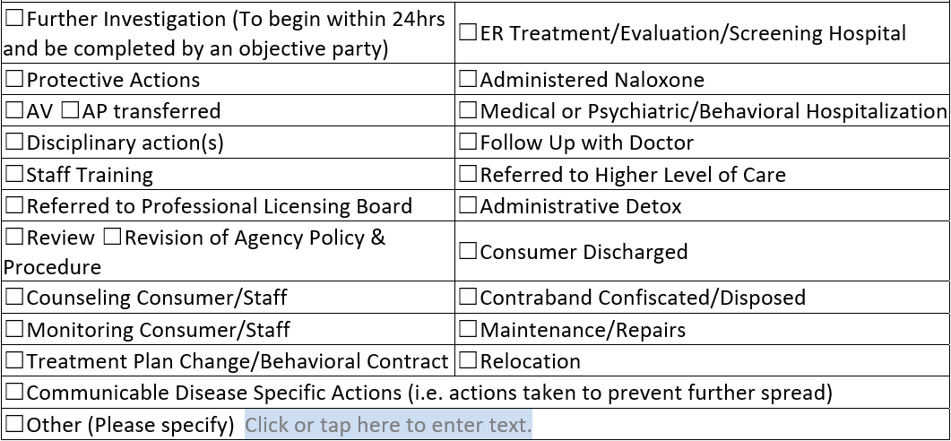 | Select all immediate actions taken and/or planned. Options have been provided for selection. If your action is not listed, select “Other”.
Detailed description of actions taken/additional information:  Click or tap here to enter text. | Include a description/further details (i.e. name of hospital, treatment received, referral information, name of training, type of disciplinary action, etc.). Be specific in defining ALL actions in the space provided. Include dates of follow-up appointments or meetings, if applicable.

